Multi-Sensory
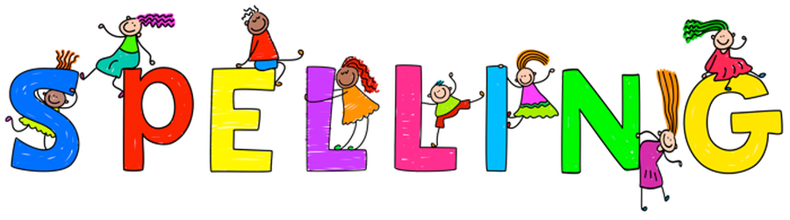
Strategies

It is really important that you as parents and carers are involved in helping your children to learn their spellings. Confidence in spelling allows children to write more freely and imaginatively in all areas of their learning.
Children, you should practise your spellings for 5–10 minutes EVERY day.
Here are some games and ideas you could use in addition to your Spelling Shed activities.
Why not try a different one each day to keep it fun and interesting?
Remember everyone learns by: doing it, seeing it, saying it, writing/drawing it and listening to it, so making sure you have a variety of games and tasks is a great way to ensure the learning sticks!


Fairfield First School
- Word Search:
Create your own word searches using your spelling words.

- Air Spelling:
Choose a spelling word. With your index finger write the word in the air, slowly say each letter. Your parent/carer needs to remind you that you need to be able to ‘see’ the letters you have written in the air. When you have finished writing the word underline it and say the word again. Now get your parents/carers to ask questions about the word. For example, they could ask, ‘What is the first letter?’ ‘What is the last letter?’ ‘How many letters are there? etc.

- Media Search:
Using a newspaper or magazine, you have 15 minutes to look for your spelling words. Circle them in different colours. Which of your spelling words was used the most times?

- Tricky Bit:
Write your spellings out using a different colour for the bits you find ‘tricky’.

- Shaving Cream Practice:
An easy way to clean those dirty tables is to finger paint on them with shaving cream. Squirt some on the table (with your parents/carers permission and supervision) and then practise spelling your words by writing them with your finger in the shaving cream.

- Salt Box Spelling:
Ask your parents/carers to pour salt into a shallow box or tray (about 3cm deep) and then practise writing your spellings in it with your finger.

- Scrabble Spelling:
Find the letters you need to spell your words and then mix them up in the Scrabble bag. Get your parents/carers to time you unscrambling your letters. For extra maths practice you could find out the value of each of your words.

- Pyramid Power:
Sort your words into a list from the easiest to hardest. Write the easiest word at the top of the page near the middle. Write the next easiest word twice underneath. Write the third word three times underneath and repeat until you have written all of your words with the hardest one written the most at the bottom.

- Ransom Note:
Cut the letters needed for your spellings from a newspaper or magazine and glue them down to spell the words.

- Spell It With Beans:
Use Lima beans (or any dried beans or lentils) to spell out your words. If you glue them onto separate pieces of card then you have made a great set of flash cards to practise with for the rest of the week.

- Pipe cleaners, Tooth Picks, Straws and Lolly Sticks:
These are a couple of things you could use to spell your words with.

- Tasty Words:
Just like above, but this time try and find tasty things to spell your words with, like raisins. Then when you have spelt them correctly, you can eat them!

- Design A Word:
Pick one word and write it in bubble letters. Colour in each letter in a different colour. You can also try this on the computer, using different fonts, Word Art etc.

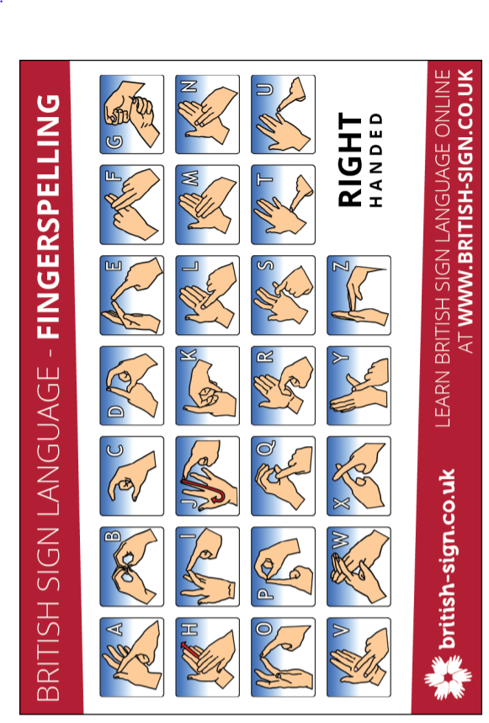
- Sign your word:
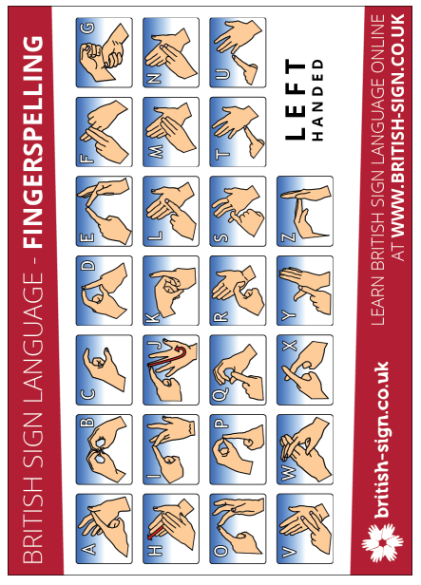
Practise spelling your words by signing each letter. (To see the British Sign Language Alphabet, see the poster below or visit: https://www.british-sign.co.uk/fingerspelling-alphabet-charts/)

- Water Wash:
Use a paintbrush and water to write your words outside on concrete or pavements.

- ABC Order:
Write your words out in alphabetical order. Then as a challenge, write them in reverse alphabetical order.

- Story Time:
Write a short story using all of your words. Don’t forget to check your punctuation too!

- Simple Sentence:
Write a sentence for each of your words. Remember each sentence must start with a capital letter and end with a full stop.

- Colourful Words:
Use two different coloured pens to write your words, one to write the consonants and one to write the vowels. Do this a couple of times then write the whole word in one colour.

- Memory Game:
Make pairs of word cards. Turn them all over and mix them all up; flip over two cards, if they match you get to keep them, if not you have to turn them over again. Try and match all of the pairs. You could play with someone else and the one with the most pairs wins!

- Finger Tracing:
Use your finger to spell out each of your words on a parent/carer’s back. Then it’s their turn to write the words on your back for you to feel and spell.

- Spelling Steps:
Write your words as if they are steps, adding one letter each time – it is much easier to do this on squared paper.

- Scrambled Words:
Write your words and then write them again with all of the letters mixed up.

- X-Words:
Find two of your spelling words with the same letter in and write them so they criss-cross.

- Ambidextrous:
Swap your pen into the hand that you don’t normally write with. Now try writing out your spellings with that hand.

- Telephone Words:
Translate your words into numbers from the phone keypad.

- Secret Agent:
Write out the alphabet and then give each letter a different number from 1-26 (a=1, 2=b, c=3 etc). Now you can spell out your words in code.

- Missing Letters:
Ask someone to write out one of your words lots of time on a piece of paper, but each time they have to miss out a letter or two. Then you have to fill in the missing letters. After you have checked them all try it again with another word.

Remember, practising little and often every day will help you learn your spellings and remember them forever!

