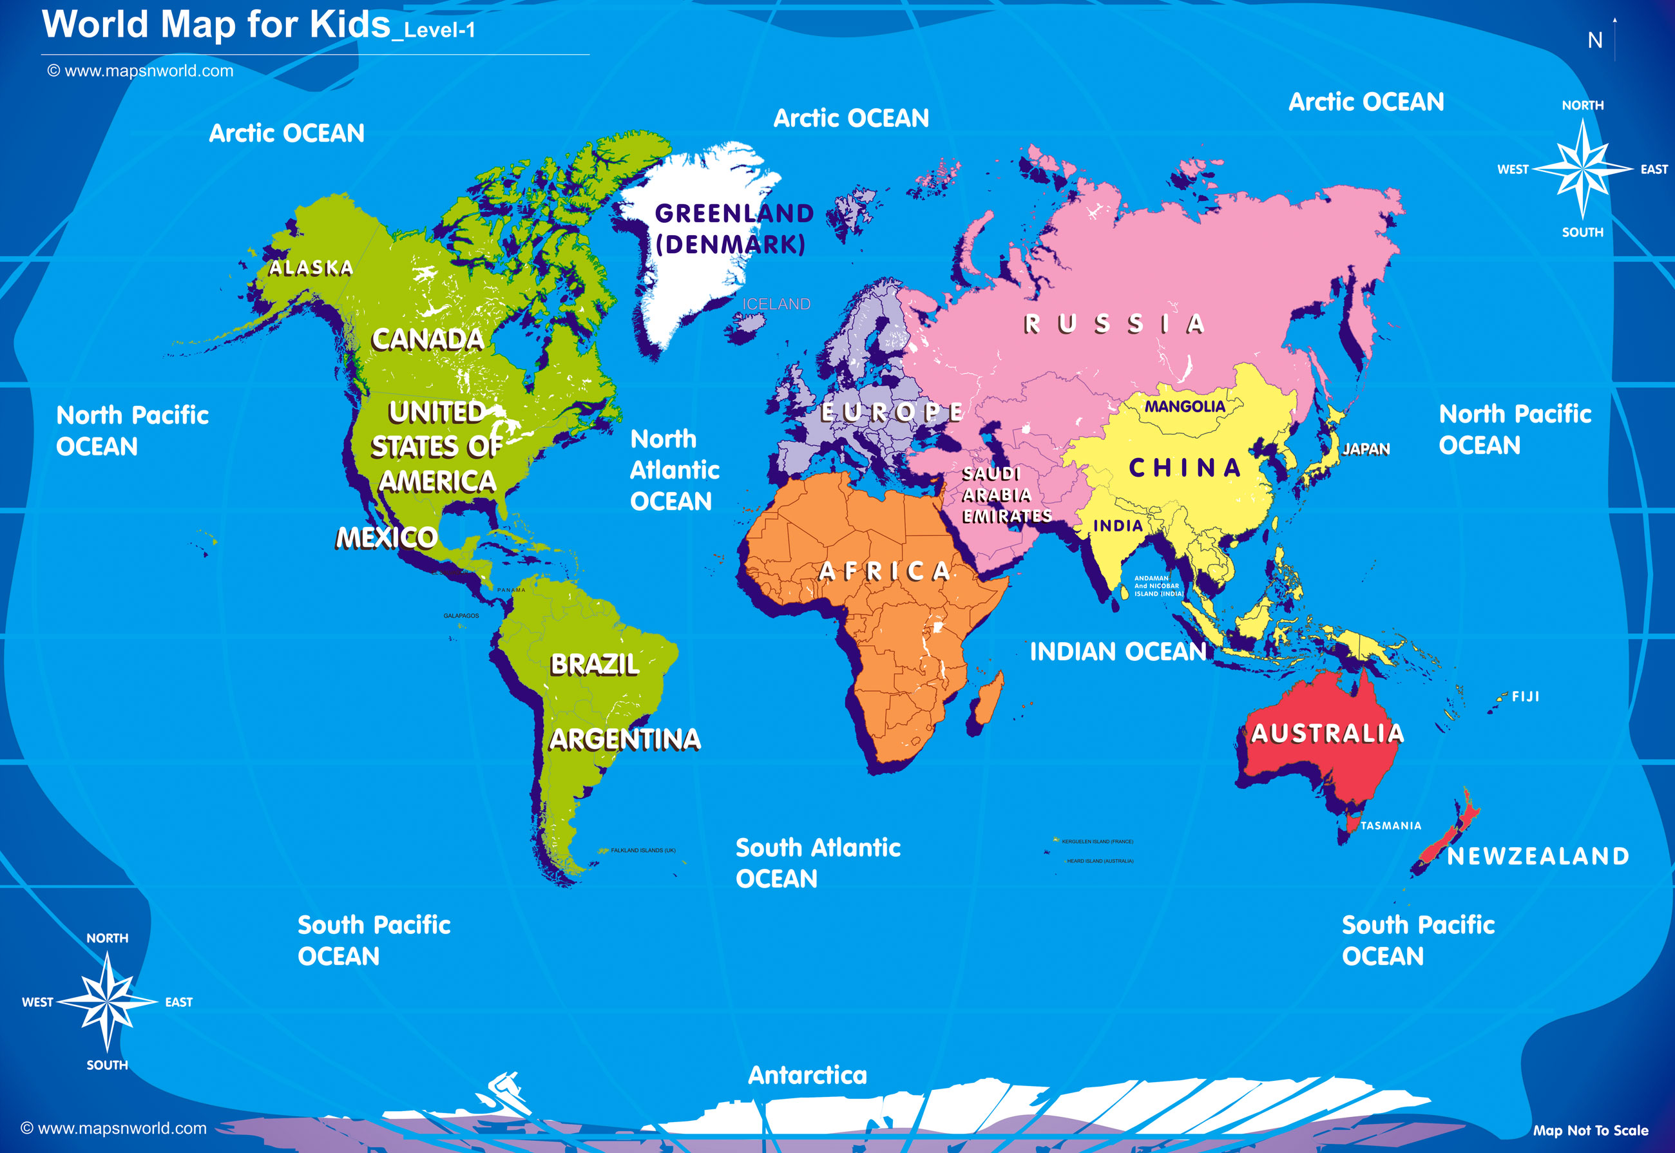
Physical Development
We will be further developing our agility, our balance and our strength through our play, our Forest School sessions and our PE lessons. This term we will be enjoying outdoor games and also trying our hand at athletics and alternate sports! We will also be training hard for Sports Day by learning skills to help us be the best that we can.

Communication and Language
We will continue to talk to each other about lots of different things including how we are feeling and to express our wonderful ideas. We will speak in full sentences and back and forth conversation will be encouraged using new vocabulary acquired. Children will be encouraged to tell us their news and listen quietly while others are talking. We will continue to ensure our pronunciation of words is the best it can be.
Personal, Social and Emotional Development
We will continue to be aware of our own feelings and be able to express how we are feeling and think of strategies to regulate ourselves. We will continue to understand each other’s feelings and remember that sometimes we have to wait before it is our turn. We continue to practise being patient. We will be trying hard to complete tasks that we consider difficult by instilling an attitude of resilience and perseverance. We will continue to improve our independent management of ourselves including understanding the need for good oral hygiene.

Oak Class – Summer Term 2026

Literacy
In our phonics lessons this term, we shall be moving onto Phase 4 of our Little Wandle Scheme. We will be concentrating on reading more difficult words with fluency and expression as well as demonstrating understanding of what we have read. We will continue to fine tune our handwriting, try hard to spell words that we write using our phonics knowledge and we will begin to write simple sentences that can be read by others. We will begin the term by enjoying traditional tales such as Jack and the Beanstalk, Goldilocks and the three bears and Three Little Pigs. We will continue to immerse our little readers into many wonderful stories encouraging them to be little authors themselves.

Maths
Our mathematical journey will continue by having a deeper understanding of numbers to 10 and by looking at patterns which arise as we count further, through the teen numbers and all the way to 100 and beyond! We will consolidate our knowledge on comparing numbers, and will introduce concepts such as doubles, odds and evens and sharing quantities. We will consider measuring and weighing items as well as looking at 2D and 3D shapes.
I wonder where our journey will take us?



Understanding the World
During this term, we will be thinking of how things were in the past as we have our class trip to the Think Tank. We will be looking at things from history as well as trying out the science experiments in the garden there. As we will be celebrating the summer season, we will be thinking about holidays and the seaside. We will study our oceans and how to protect them as well as taking a look at other people and other cultures around the world. We will start our journey in Fairfield, moving through Bromsgrove, Worcestershire and England. From there we will move on to other areas of the world.

Expressive Arts and Design
As always, we will take lots of opportunities to showcase our artistic talents through painting and colouring using different media. We will be designing and making creations at our creation station and will be using junk modelling to create our village later in the term. As always, we will be singing and dancing, whenever the opportunity arises.

