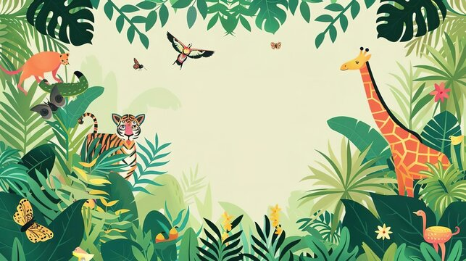
Expressive Arts and Design
As always, we will take lots of opportunities within our topics to explore different ways of showcasing our artistic talents. We will draw and colour with pencils and pastels. We will choose animals to draw step by step and use paint mixing to enhance our creations. We will use different media to create animals and in Design Technology we will try our hand at some stitching and making junk models.
Understanding the World
As we return to school, we will think about the season of winter. What does winter look like? We will think about a mysterious egg that has appeared in class. What could it be? Where has it come from? Which animals lay eggs? We will move on to think about other animals and how we can classify them. We will think about where they live, what their habitats look like and how they survive. An exciting aspect of this term is a visit from the Animal Man and his exotic pets and also we will have our own chicken eggs to hatch! We will learn about Easter and celebrate this Christian festival together.

Maths
We continue our mathematical journey by consolidating our knowledge of numbers to 10 We will delve deeply into numbers to 10, recognising what these numbers mean and how they are made from other numbers. We will sing number songs and count accurately. We will be consolidating our knowledge and understanding of comparing and ordering numbers as we become able mathematicians.
Physical Development
We will continue to develop our fine motor skills every day to help us to become early writers. We will learn to use cutlery correctly. Our gross motor skills such as balance, agility and co-ordination be developed outside in the playground and on the trim trail as well as through our PE lessons of gymnastics and ball skills.

Personal, Social and Emotional Development
We will continue to be aware of our own feelings and think of strategies to regulate ourselves. We continue to display good manners remembering to say thank you when appropriate. With our friends, we will continue to understand each other’s feelings and remember that sometimes we have to wait before it is our turn. We will practise dressing ourselves independently and managing our hygiene needs independently.

Communication and Language
Children will be encouraged to speak correctly and in complete sentences. They will have the opportunity to talk with friends and with adults in all areas of the curriculum. Back and forth conversation will be encouraged using new vocabulary acquired.
I wonder what’s inside?
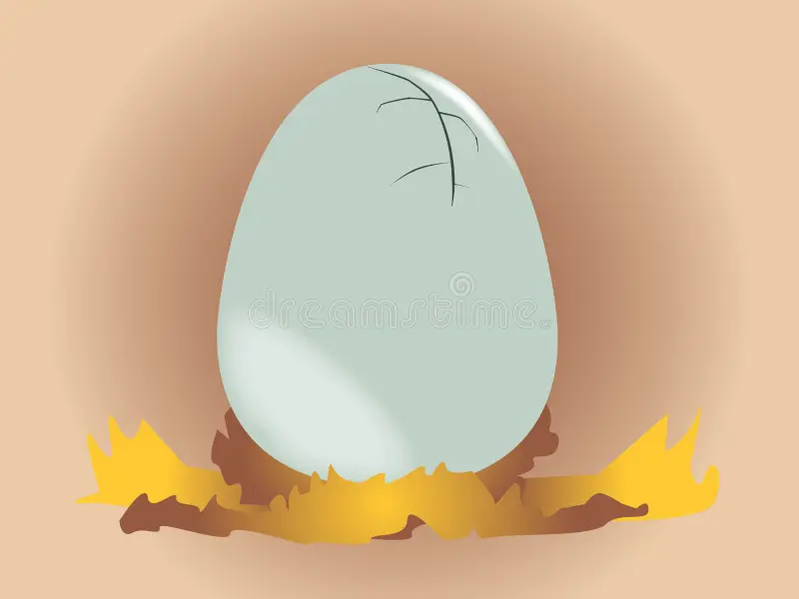

Literacy
We continue our reading journey by learning our digraphs during our phonics sessions. Having mastered blending our sounds, we will develop our fluency in reading together with prosody and comprehension. We will listen for words that rhyme and we will listen, talk and re-tell stories. We will extend our vocabulary learning new and exciting words. We will listen to lots of new stories; we will engage in National Storytelling week by inviting parents to come and read their favourite children’s story. We will have lots of opportunities for writing and start labelling pictures and writing captions and small sentences.
Oak Class – Spring Term 2026

