Research - Food Origins | Writing - Food Journal | Art - Food Map
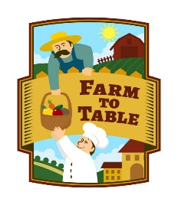  Pick your favourite food. Where does it come from? Draw a picture of it and write a few sentences about its journey from farm to table. | 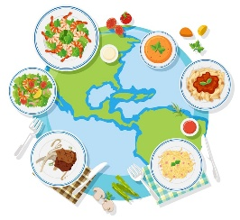  Write down what you eat for three days. Then, draw a map showing where those foods are from. | 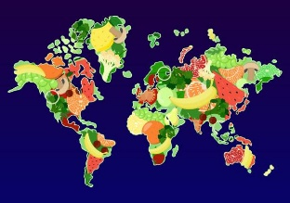  Create a colourful map of the world with at least 5 foods and the countries they come from. Label them clearly!
Presentation - Food Story | Where Does Our Food Come From?  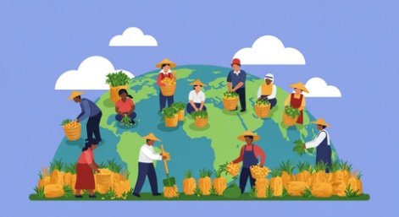  Homework Grid  Autumn 2 2025 | Maths - Food Facts
Prepare a short (3-minute) talk about a food you love. Include where it comes from and a fun fact. You can use pictures or drawings to help! |  | Find out how many bananas or apples are grown in a certain country. Create a simple graph to show your findings.
Community Connection - Meet a Farmer |  | Environmental Study - Effects of Deforestation
If you can, interview a local farmer or shopkeeper about where their food comes from. Write down what you learned in a few sentences. |  | Write a short paragraph about how cutting down trees can affect food. Give at least 1 example.
Cooking - Family Recipe |  | Science – Fair-Trade
Make a meal with your family using ingredients from different places. Write down where each ingredient comes from and draw a picture of the meal! |  | Choose a fair-trade product (like chocolate or coffee). Write a few sentences about what fair trade means and why it's important.
Geography Climate Comparison | Creative Writing Food Journey Story | Art & Craft Food Collage
Create a Venn diagram to compare temperate and tropical areas. What foods grow in each? Draw or write your answers!  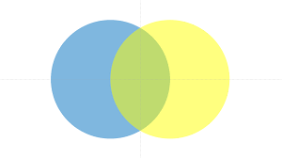 | 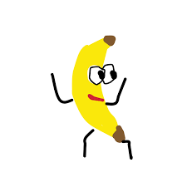  Imagine you are a piece of food (like a banana or pizza). Write a short story about your journey to a restaurant or someone's home. | 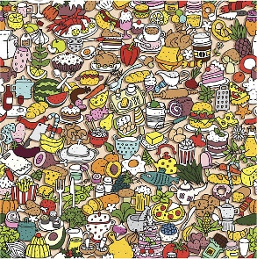  Make a collage from old magazines showing foods from different places. Label where each food comes from.

